VARIEGATED LEAVES
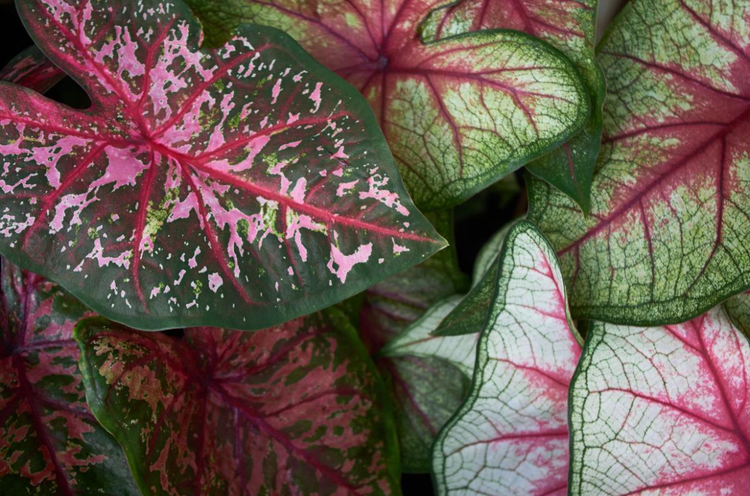
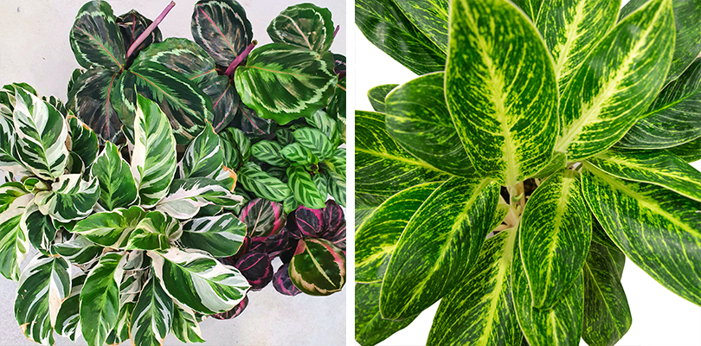
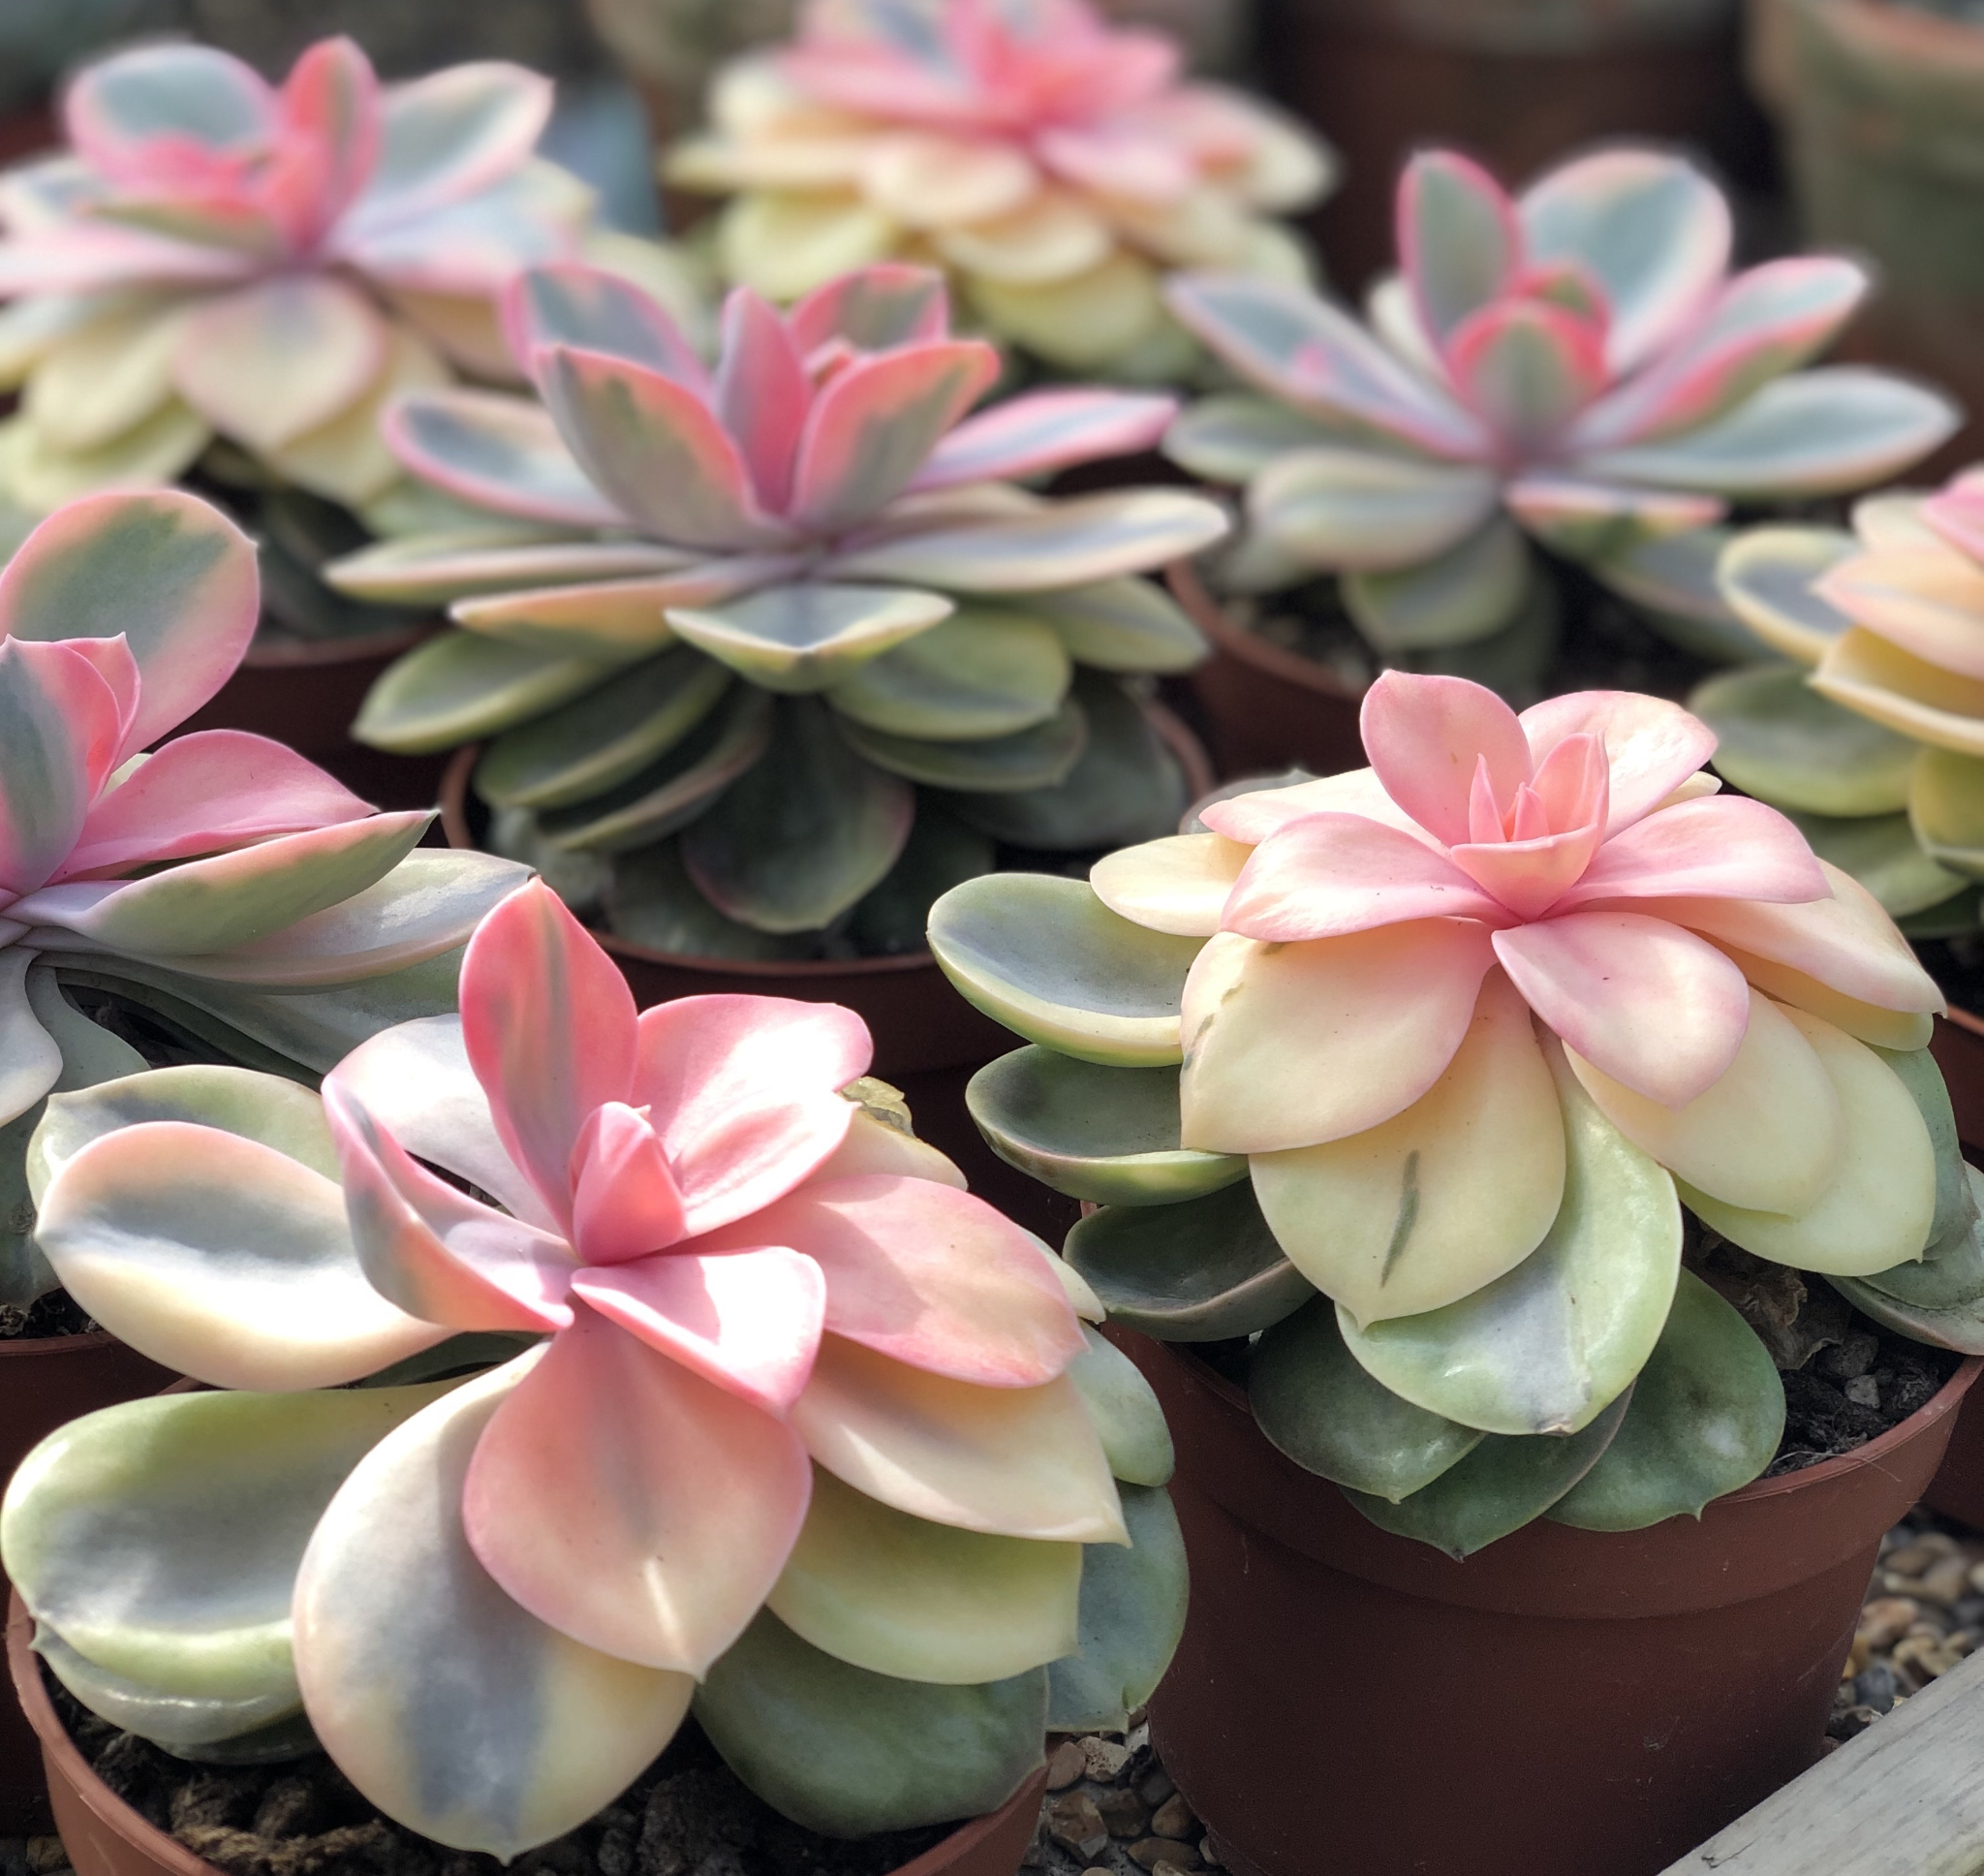

PLASTIDS
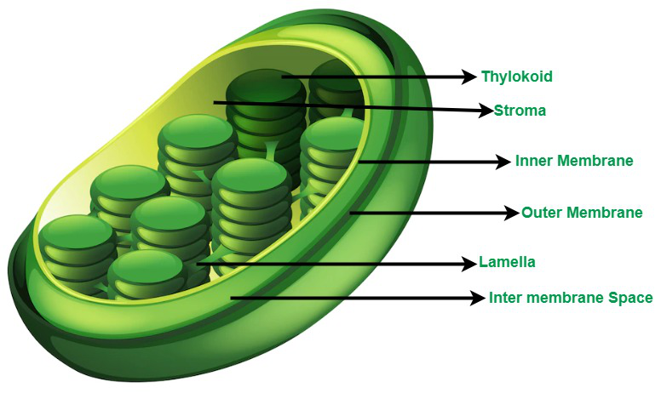

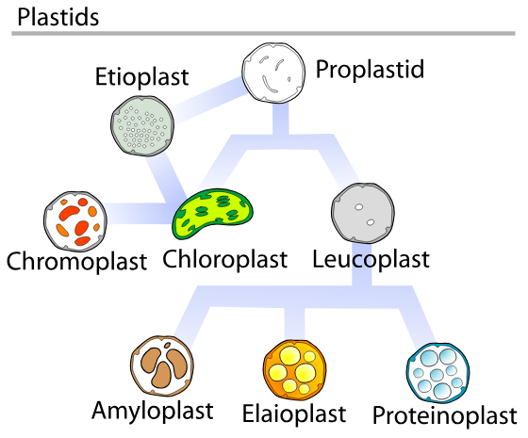
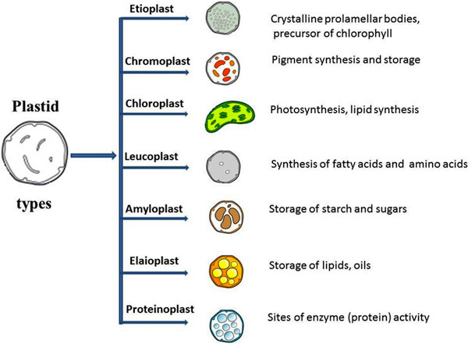
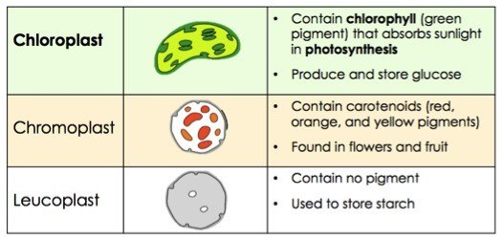

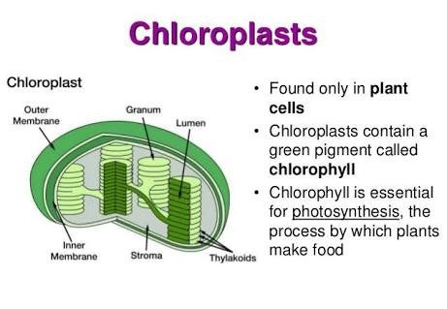
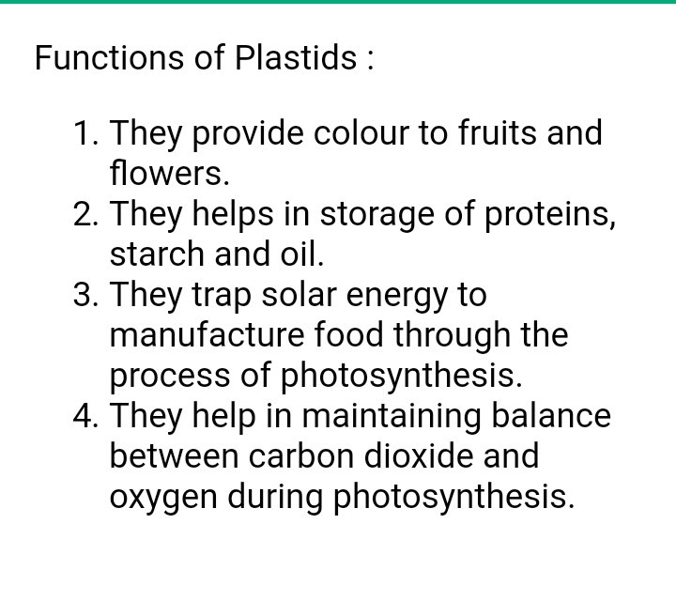
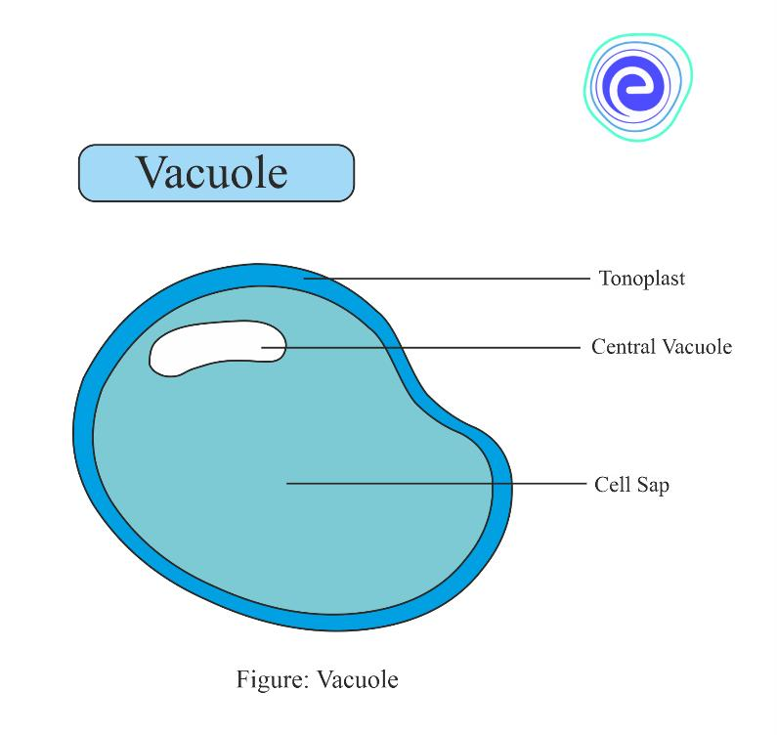
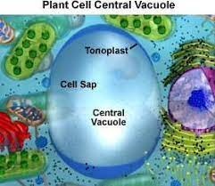
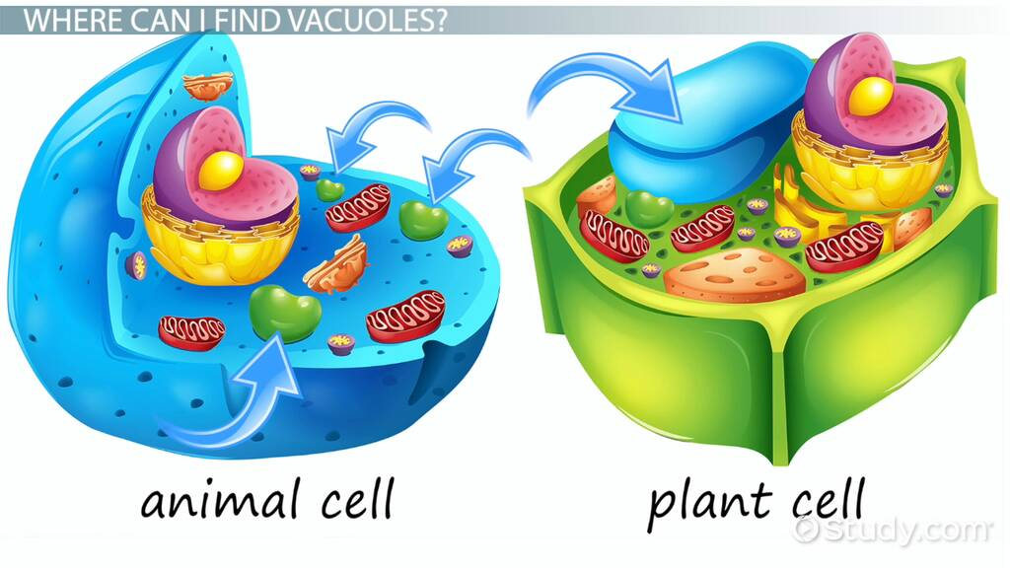

What is Vacuole?
The term vacuole means “an empty space”. Vacuoles are enclosed space that contains water, inorganic and organic molecules, and enzymes in solution. In some cases, they may also contain engulfed solids. Vacuoles are found in almost all eukaryotic species, including animal and plant cells. They are formed from the fusion of multiple membrane vesicles.

Vacuoles have a distinct shape and size, which depends on the components that make up the vacuole. In plants, algae, and fungi, vacuoles protect the cell against self-toxicity. The other function of the vacuole includes controlling osmotic pressure, preserving ion concentration, storing amino acids, preserving cell homeostasis, and carrying out degradation processes.
Animal vacuoles are known to carry out various functions such as cell protection, recycling, endocytosis and exocytosis, storage, and maintaining turgor pressure.

. What is the Main Function of Vacuoles?
Answer:
The primary function of vacuoles is to store various substances, including water, ions, sugars, pigments, toxins, and waste products.

What are Vacuoles Made of?
Answer:
Vacuoles consist of a membrane (tonoplast) made of lipids and proteins, surrounding a fluid called cell sap, which contains water, ions, sugars, pigments, and other dissolved substances.

. What is the Role of Vacuoles in Intracellular Digestion?
Answer:
Vacuoles are involved in intracellular digestion by absorbing dietary substances through endocytosis and excreting waste through exocytosis. Lysosomes attached to vacuoles contain digestive enzymes.

Where is the Vacuole Found?
Answer:
Vacuoles are found in the center of a cell. They vary in size and shape depending on the type of cell. Plant cell vacuoles are very large in size and store large amounts of water. Vacuole also helps the plant maintain its firm shape.

5. What are the Different types of Vacuoles in the Cell Membrane?
Answer:
They are classified into three groups depending on their contents and functionality.
- Sap vacuoles
- Food vacuoles
- Contractile vacuoles
CELL DIVISION
The division of a cell into two or more daughter cells is called cell division. Eukaryotic cells divide by two methods- Mitosis and Meiosis. Prokaryotic cells divide by Amitosis /Binary Fission. Mitosis: The process cells use to make exact replicas of themselves. Mitosis is observed in almost all the body’s cells, including eyes, skin, hair, and muscle cells. Meiosis: In this type of cell division, sperm or egg cells are produced instead of identical daughter cells as in mitosis.
CELL DIVISION
Cell division plays an important role in all living organisms, as it is essential for growth, repair and reproduction. This process helps in: Renewing of damaged cells. Production of new cells from older ones.

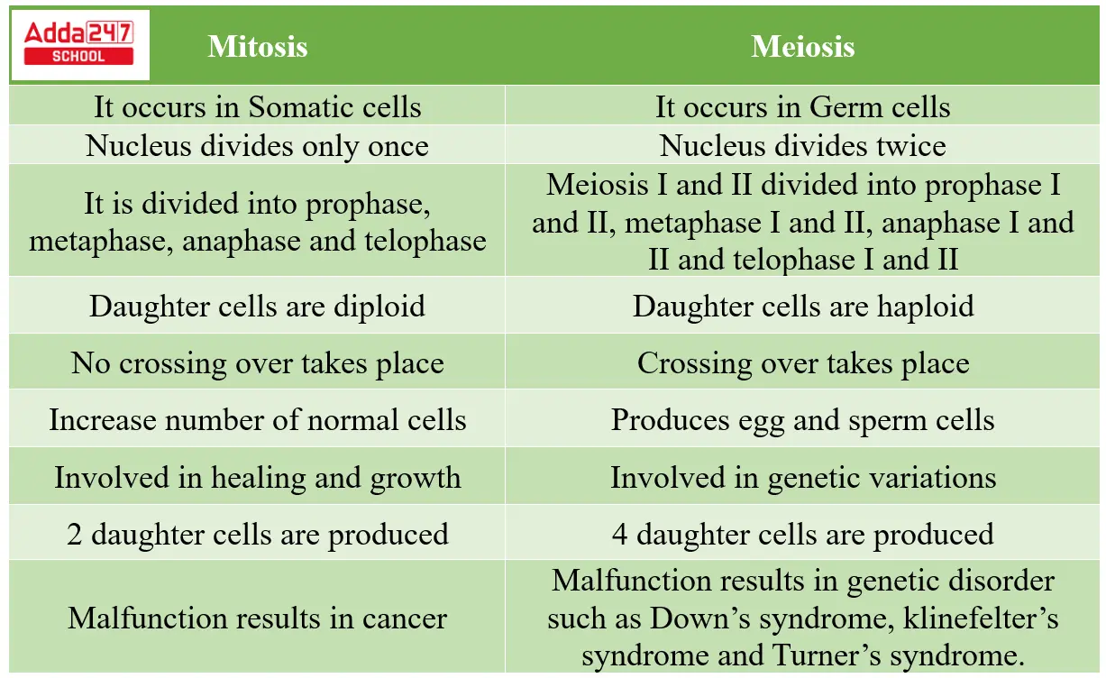
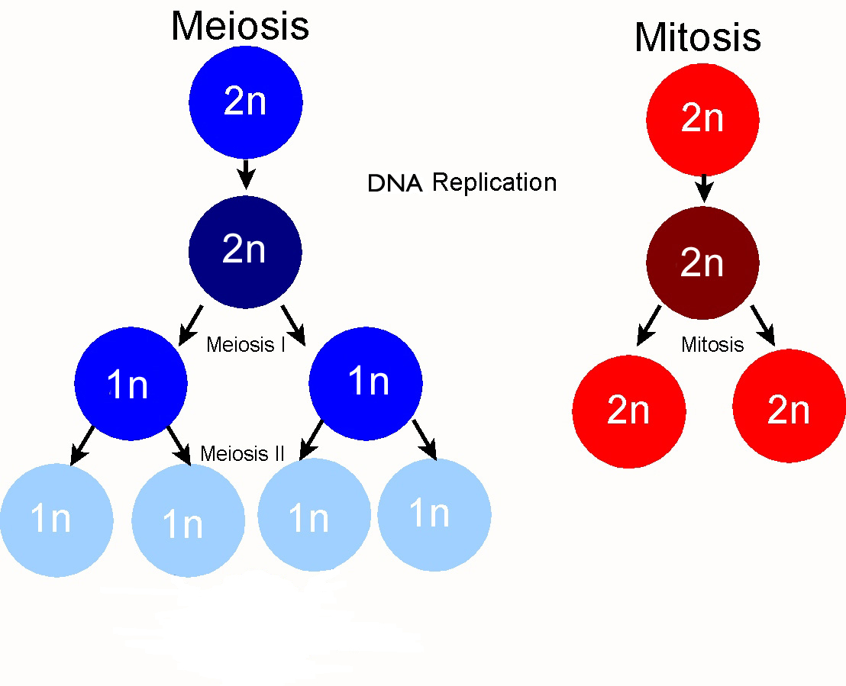

MITOSIS
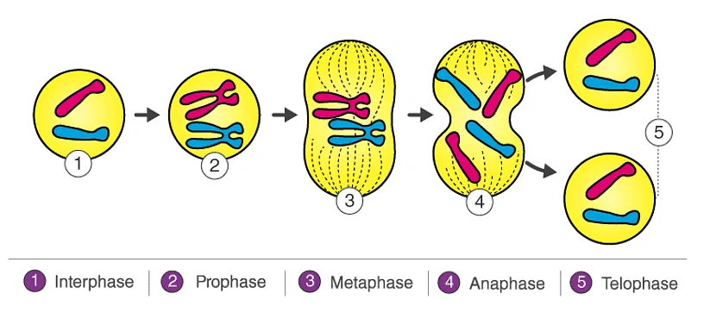

MEIOSIS
